Aaron Snyderburn

Professor Adams

STA 147

Lab 8

1. Finding an area, given a value of the variable.

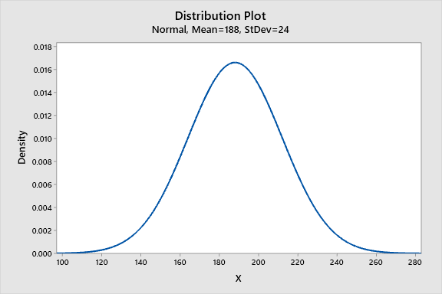

1. Option 1.

Normal with mean = 188 and standard deviation = 24

x P( X ≤ x )

200 0.691462

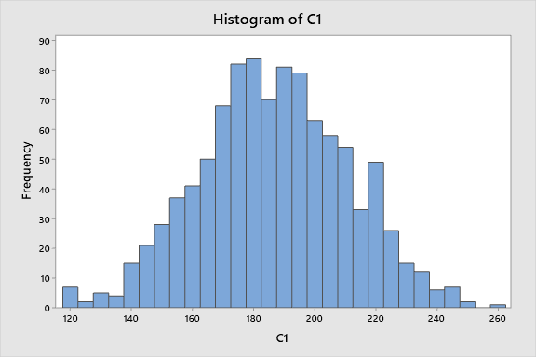

2. Find the probability.

Normal with mean = 100 and standard deviation = 15

x P( X ≤ x )

125 0.952210 . The probability is 0.95221



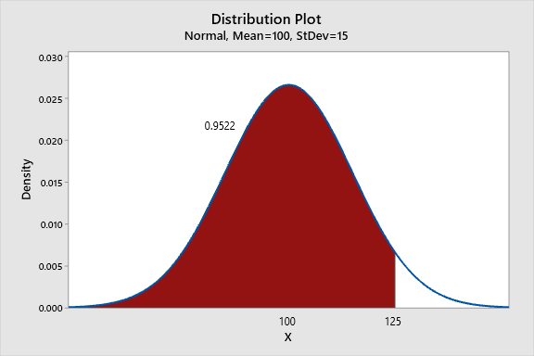

5.